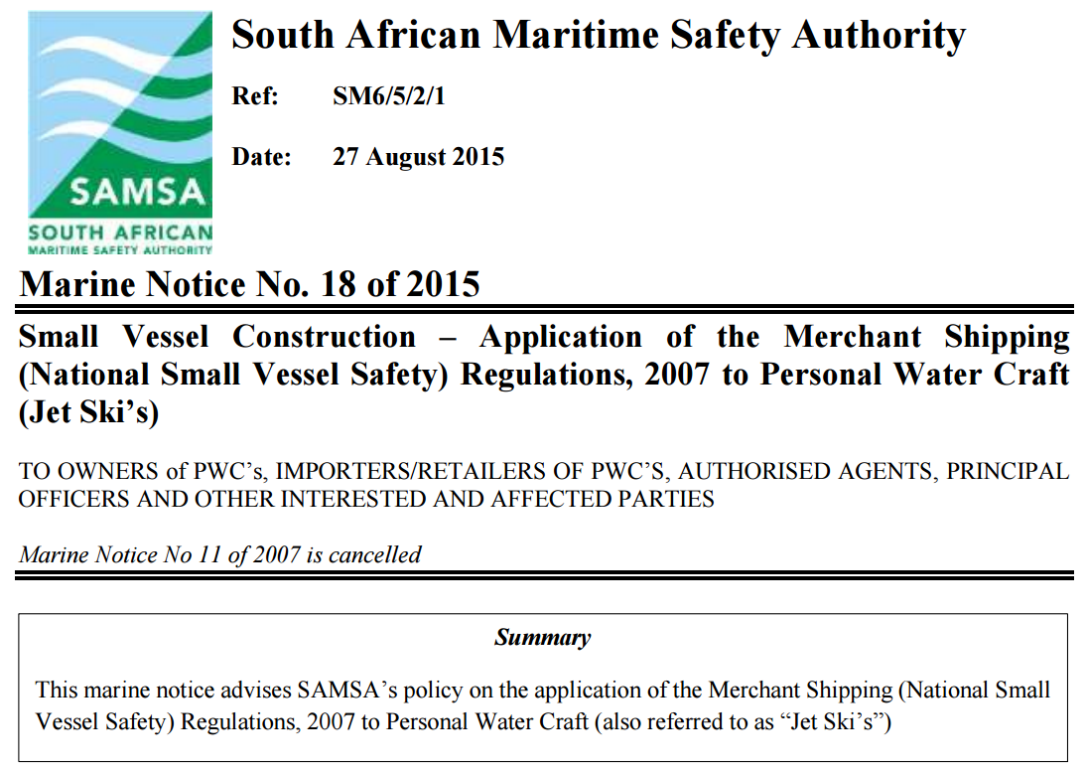
4.2 Alterations and/or Additions No alterations or Additions may be made to the PWC which affect the vessel’s compliance with SANS/ISO 13590 or equivalent standard.
Where alterations/additions to a PWC are made, it shall be the responsibility of the importer, retailer, builder or owner to prove to the satisfaction of SAMSA that the design and construction of the vessel remains in compliance with the applicable standard with regard to:
a. Hull strength.
b. Vessel built-in buoyancy.
c. Fuel arrangements.
d. Electrical arrangements.
e. Vessel maneuverability.
Where alterations or additions are made to a PWC, an endorsement must be attached to the owner’s manual of the PWC by the manufacturer/person making such changes clearly identifying the scope of the change and confirming that the alteration/addition do not affect the inherent design of the vessel.
Alterations/additions made to the PWC may not result in the maximum recommended load, as specified on the builder’s plate, being exceeded.
OUR SOLUTION INCREASES THE MAXIMUM RECOMMENDED LOAD BY ± 500KG WITH ADDITION OF LIGHTWEIGHT INFLATABLE BUOYANCY /STABILITY PONTOONS
4.3 Fitment of Side Attachments(“Tubbies”) Fitment of side attachments must comply with the provisions of paragraph 4.2. In particular the construction must be such that the PWC must be able to pass a “Drop Test” as specified in SANS/ISO 13590; viz, fully loaded PWC dropped horizontally from a height of 2.5m with no structural failure occurring
OUR SOLUTION IS A SLIDE ON (2 MINUTES) & SLIDE OFF (½ MINUTE) SOLUTION – THE OWNER OF THE PWC REMOVES THE PONTOON (NOT A PERMANENT FIXTURE), HAS HIS SAMSA COF INSPECTION DONE . . . AND THEN SLIDES ON THE PONTOONS BEFORE HE LAUNCHES.
5.1 As built Stability and Built-in Buoyancy/Floatation PWC’s designed and constructed in accordance with SANS/ISO 13590 are:
b. Designed so that when the PWC is floating upside down, the operator must be able to return the PWC to the upright position, and go on board again.
OUR SOLUTION ALLOWS THE CAPSIZED SKIPPER TO DEFLATE EITHER THE PORT OR STARBOARD BUOYANCY STABILITY PONTOON AND SLIDE IT OFF THE HULL, IN LESS THAN A MINUTE – Without the need of any tools or an assistant . . . THAT WILL ENABLE HIM TO UPRIGHT THE PWC WITHOUT ANY FUSS . . .
However; a permanently fitted FIBERGLASS OUTRIGGER STOWAGE BOX (“Tubbie” or Jet Wing) makes this exercise impossible.
OUR SOLUTION ALLOWS ALSO DRAMATICALLY REDUCES THE RISK OF A JET SKI CAPSIZING, BECAUSE OF THE ADDITION OF ± 250KG BUOYANCY OUTRIGGERS ON BOTH SIDES
5.2 Alterations and/or Additions Alterations or additions must comply with the following:
a. Alterations/additions made to the PWC may not result in the maximum recommended load, as specified on the builder’s plate, being exceeded. Additions made to a PWC may accordingly result in the number of persons for which the PWC is certified being reduced for example.
b. Where alterations or additions are carried out to the vessel which increase the weight of the vessel with weight(s) which will not fall free of the vessel in the event of capsize and where this additional weight is in excess of 5% of light weight of the PWC, it must be ensured that additional built-in buoyancy is provided for the PWC to:
i. Ensure that the vessel will remain positively buoyant when submerged for a period of at least 18 hours.
ii. Ensure that when the PWC is floating upside down, the operator is still able to return the PWC to the upright position, and go on board again. MN 18 of 2015 Page 5 of 6
THE ADDITIONAL BUOYANCY MAY BE PROVIDED ON THE PWC OR AS PART OF THE ADDITIONAL FITTING/component e.g.
SIDE ATTACHMENT(S) COULD BE PROVIDED WITH SUFFICIENT BUOYANCY TO SUPPORT THE WEIGHT WHICH THEY ARE DESIGNED TO CARRY.

