Article written by the Owner/manager of this website

Maximising your bass fishing dinghy

My boat business has been associated with the boating fraternity since 1989. I have noted with keen interest the evolving market trends, new consumer preferences, new products and solutions & the like.

It would appear that species angling and in particular bass angling, has grown in popularity in leaps and bounds. The allure of putting the hustle and bustle of city behind you and relaxing in the tranquillity and serenity of the great outdoors, has become the stress reliever panacea of the impinged urban dweller. Coupled with the exhilaration of the “hunt” & you have a thriving sport.

With this boom has come a deluge of inflatable products, that allows you to get within striking distance of the ever elusive trophy fish. Inflatables obviously appeal to city folk, because of stowability in constrained spaces.

Specie angling boating has become a substantial part of my customer base and I have deemed it prudent, to elucidate on some Frequently Asked Questions. (FAQ)

(FAQ) How do I care for my boat and extend the life expectancy of my boat?
- Nothing has a more detrimental effect on your boat than Direct Sunlight.
Invest in a 90% shade net and hem in a light chain on the 4x edges. Drape the net over your boat, when it is lying on the shore and is basking in the sun
- You do not want the sun to heat up the air inside your pontoons, to the extent that air starts to expand and causes undue strain on the seams (Prescribed air pressure ought to be 0,25 bar)
- All your trimmings such as handles, row locks, transom mouldings, grab rails, etc will remain bonded to the pontoons for a much longer time
  - Sunlight & UV exposure causes premature boating problems
- NEVER cover your boat with a dark boat cover (red/royal blue/ dark grey etc) The heat build-up between the boat cover and the boat is so intense, that it could be equated to parking your boat in an oven. You are literally cooking your boat to smithereens (also your fish finders transducer cables, fuel line hoses, etc)
- Over inflating due to temperature extremes, can be ameliorated with the fitment of a calibrated Safety Pressure air release dump valve. I should caution against the sole reliance on the safety valve. They are calibrated to prevent premature air dumping & will only dump air once your boat has reached it uppermost maximum air pressure (You don’t want to drive your car with the rev counter in the red?)
See YouTube video for more info https://www.youtube.com/watch?v=pw73tEYF29c
- When travelling abroad with an inflated boat on a trailer, you should take cognisance of the departure & arrival altitude. Let me explain; a weather balloon rises and expands until it eventually bursts, because of the lack of air pressure at altitude. The reverse is also true. A scuba diver experiences a dramatic increase in pressure, when he descends. The prevalent atmospheric pressure will influence your boat’s innate air pressure in the same manner. Your pontoons will deflate when you descend to your coastal holiday destination. On your return leg, you should manually dump ±30% of the air, when you pass through Van Reenen's Pass toll gate, at the foot of the escarpment.
- Seasonal changes also dictate what time of the day you should inflate your boat. When you have to contend with day & night temperature extremes, the it would be best to inflate your boat in the heat of the day (at noon) The hot air in your pontoon, will not expand any further, because of the highest ambient temperature of the day (Providing you do not inflate & then park in direct sunlight!)

- Clean your boat twice a year with a normal vinyl kitchen floor cleaner such as Pledge / One Step
  - A Vinyl kitchen floor cleaner/polish will firstly clean your boat, nourish the PVC fabric & finally add a lustre and sheen (polish) to the pontoon
  - Also spray some Q20 into the valve orifice. This lubricates the valve mechanism and keeps the valve diaphragm soft and supple, ensuring an air tight seal

- Do not drag your boat onto the shore . . . especially by the bow tow point, while the outboard is mounted on the transom

Not all transoms are manufactured from marine ply; the dragging causes the material under the transom to become threadbare, exposing the raw wood. Water ingress into your boat’s transom, induces wood rot.

This can be prevented by lifting the boat at the transom, or by fitting “Inflatable Boat Launching Wheels”

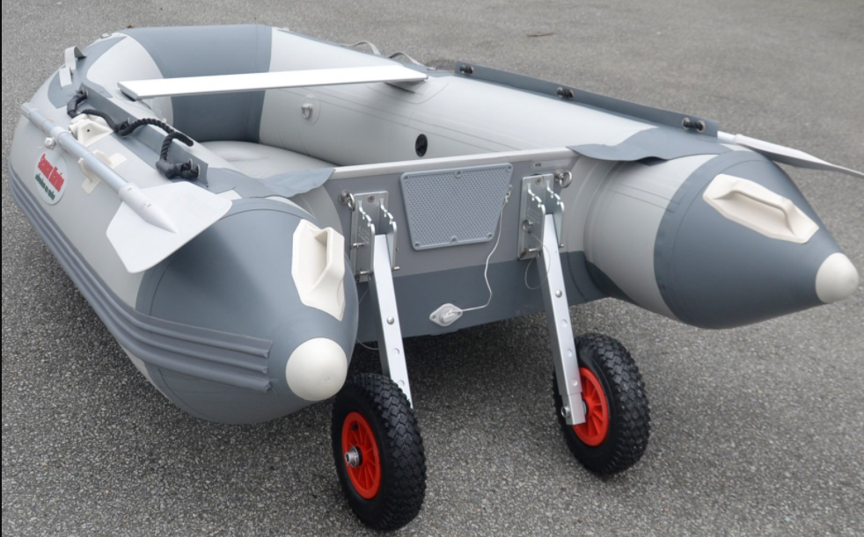

If your transom is already scoured underneath, you can weld a piece of PVC flooring underneath the transom, to dramatically extend the life of your boat’s transom.

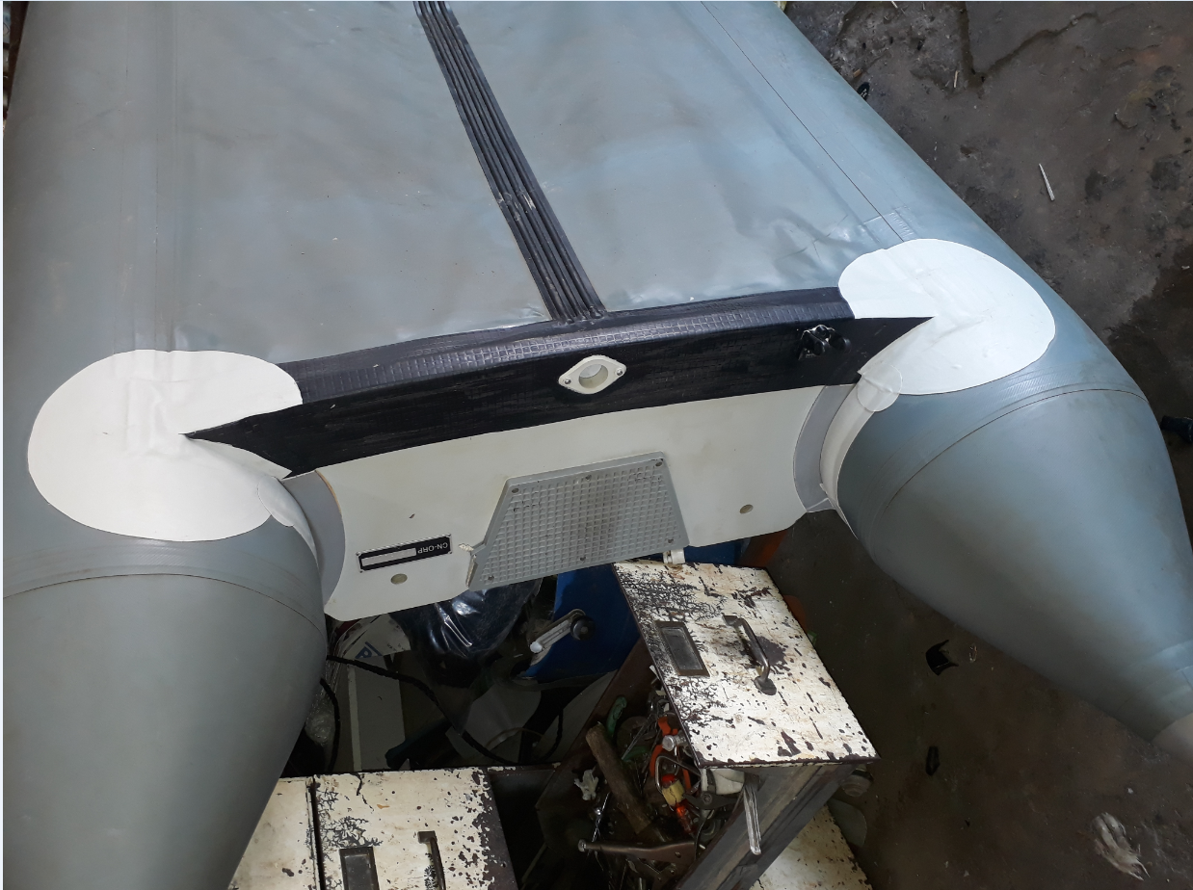

When drilling holes in your transom to fit transducers etc, make sure that you have used ample Marine Silicon to seal the holes & cover the stainless steel screws.

Water tends to accumulate, under the floor board, in the port & starboard corners of your transom. Prevent this by turning the boat on its side & allowing ALL water in the boat to drain out. This will go a long way in preserving your transom

Marine ply floorboards should be sanded down biennially (every 2 years) with a fine grit sand paper & receive a fresh coat of Marine grade outdoor polyurethane varnish.

- Take care that your boat is stowed away properly out of season
  - Make sure that the boat is bone dry, before you roll it up & stow it into its storage bag. Mould fungus contains chlorophyll that will permanently stain the pontoons, with a big dark green stain. Expect the same dire consequences if you leave your boat outdoors, full of rain water with a couple of leaves in it. (The green/brown water acts as a dye)
  - Before rolling up your boat, sprinkle some talc powder (baby-bum talc) over the entire pontoon
  - Store your boat at an ambient temperature. Leaving it in the hot corrugated iron garden shed, or in your weather exposed holiday trailer, will have the same consequence as leaving the boat under a dark coloured boat cover, basking in direct sunlight.
  - Rodents love to nest inside a rolled up inflatable. Every year I have a couple of forlorn looking burly farmers at my workshop, with rat eaten boats, that were stored in a farming warehouse.

(FAQ) How do I select a boat that complies with my specific needs?

- Do you intend to deflate and stow your boat in the boot/caravan after each successive trip? Are you going to invest in a trailer and keep your boat permanently assembled and inflated?

Deflatable boats ought to be small, light & easy to assemble. Some floorboard assemblies will leave you tired, perplexed & and with a new unsavoury vocabulary. Personally I favour the intuitive fit, aluminium floors. I have to stress, that I do not have any qualms with a well-designed marine ply floorboard.

A 2,5m long boat will allow a maximum 2x person complement; a 3,5m a maximum squeeze with 3x crew & the inflatable standard at 4,2m will even allow the intrepid angler to fish offshore.

Poorly designed trailers can incur unnecessary damages to your boat. Buy some thick proper trailer felt & glue onto trailer slides, by so doing preventing your boat’s floor from chaffing through.

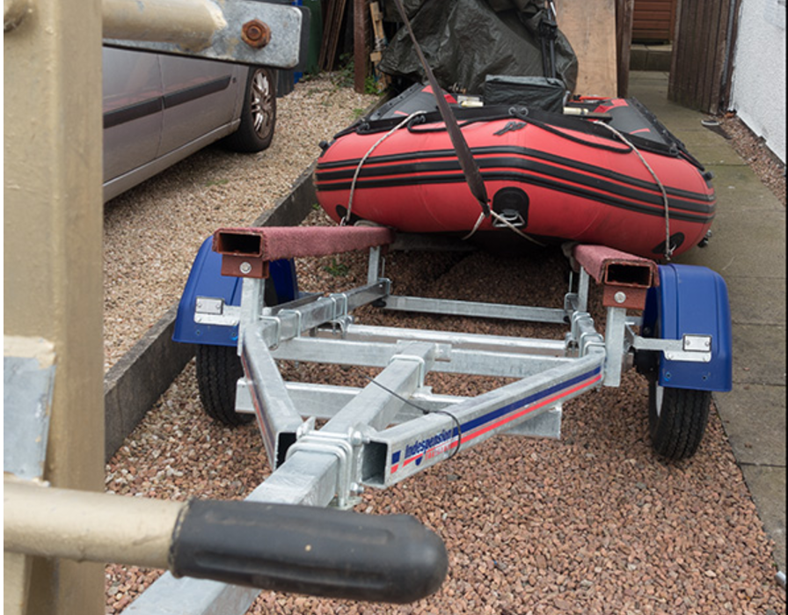

I prefer trailers with a metal beam that runs from port to starboard at the back of the trailer. Your transom should always be supported by the trailer, in case the pontoons deflates whilst in transit (which will happen on a cold winters’ night!)

Ensure that your trailer supports the boat over its full length. Some trailers do not support the bow, which leads to complications when it rains & the bow is water laden, without any trailer support.

- The South African Maritime Safety Authority (SAMSA) has certain rules and regulations that all boat owners must adhere to. Contact your nearest accredited SAMSA surveyor for further elucidation.

- In essence the rule of thumb is; you get what you PAY for. “El-Cheapo” has the reputation of coming back to bite you.
  - “El-Cheapo” no name brands are a huge No-No. If the manufacturer does not want to be identified, that ought to evoke some apprehension from the buyer. (Isn’t Brand Building vital to the success of any reputable company?)
  - Local is “lekker” providing that you stick to tried & tested reputable brands. Example: The NSRI only uses local brands.
  - The oversupply of amazing looking imports, do not always equate that they are superior in quality. There are a couple of brands out there, with transoms manufactured from Supawood. Social Media & Chat Forums fortunately has the knack of weeding out these “denizens of ill repute”
  - The quality of the fabric should also be considered, before making your purchase
A quick guideline:
- Jumping castles are manufactured from 550 gsm² cloth (grams per square meter)
- Truck tarpaulins are manufactured from 700 or 800gsm² PVC cloth
- Inflatable boats are generally manufactured from 1050gsm² imported PVC
  - Racing pencil ducks use a lighter fabric to save weight & gain speed . . . but they are normally replaced by their sponsors after a season or two
- To my knowledge 1450gsm² is the most expensive/durable cloth available in South Africa, but is too heavy & expensive, for the purposes of this article.

(FAQ) How do I enhance or improve my RIG?

Obviously the owner wants to contend with as few maintenance issues as possible
- As mentioned before. Invest in a 90% shade cloth cover. That should be your first priority.
- If your fishing pursuits compel you close inshore, where branches and other “puncture dangers” lurk, you could invest in armouring the bottom pontoons with PVC flooring cladding
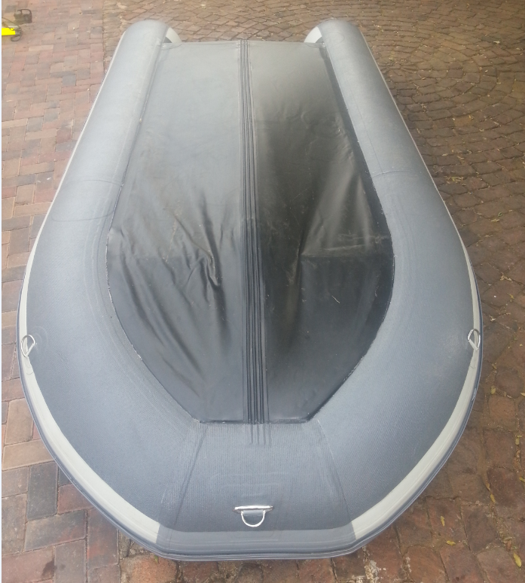
- Transoms tend to pull loose when outboard motors are left hanging on them, this phenomena is exacerbated, when the boat lies unattended in direct sunlight. Pontoon-to-transom turnbuckle brackets will virtually eliminate this problem, because they negate the “pull” of the outboard motor on the transom.
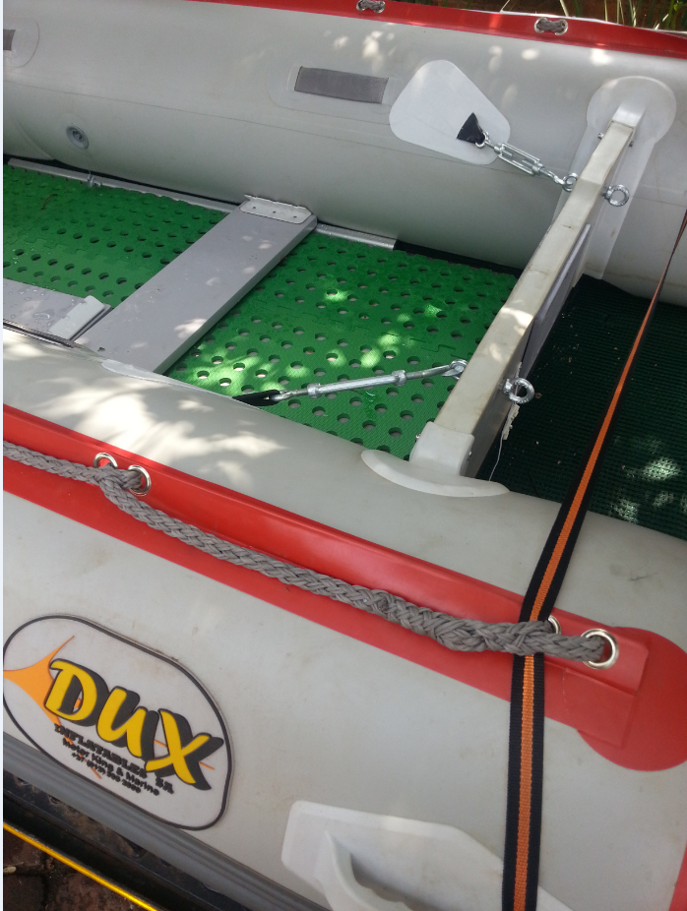
- Pontoon-to-transom turnbuckle brackets will also ameliorate “porpoiseing” boats, when floorboards tend to bend upwards. This occurs when the propeller thrust forces the bottom of the transom forward, which in turn causes the floorboards to buckle upwards. Pontoon-to-transom turnbuckle brackets hold the transom in place, preventing the outboard from pushing the transom forward
- While transporting inflatable boats on a trailer with the outboard motor in a raised position, heavy outboard engines may provide extra strain on a boat's transom. When a moving trailer hits a bump or uneven pavement, heavy motors are capable of damaging the transom. You can install a Outboard Support Pole - Adjustable, Spring Loaded from the bottom end of the trailer (vicinity of centre mounted number plate) to the rear end of the outboard motor gearbox casing (V- on pole end) in order to provide extra support for the motor's weight. These supports are available at most boat shops
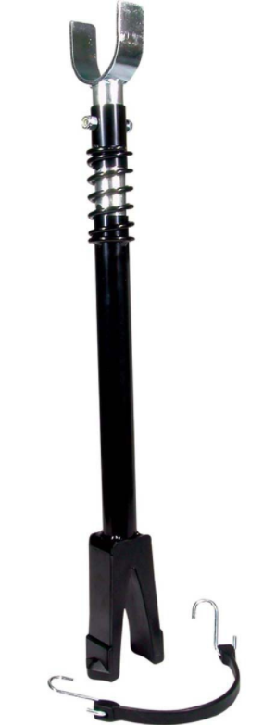
- Consult your local knowledgeable boat shop to determine the correct angle of the propeller shaft on the transom. If the propeller is tucked in under the transom, the boat’s bow will plough into the water when you accelerate, this induces the uncomfortable “porpoiseing” ride, as the bow digs in and boat decelerates; followed by a release jolt from the from the bow & a whip lash forward lunge.
- Trimming the outboard too far away from the transom, causes the bow to lift and the boat struggling to get on the plane.
- You could increase deck space, by having stowage bags slung underneath your seating benches, this liberates a considerable amount of deck space. The benches that mount onto the pontoons with a velcro strip has become popular, because you can adjust the longitudinal seating arrangement to your preference.
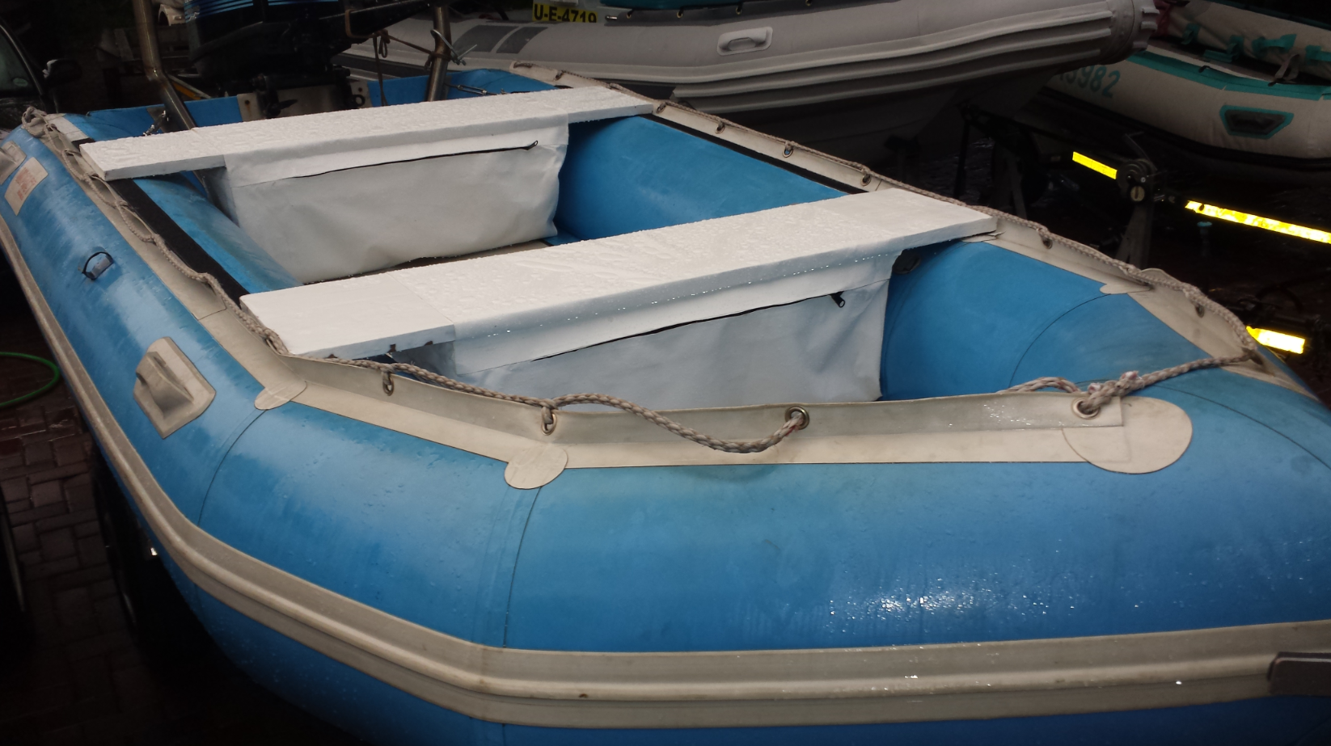

- Intex manufactures a bow transom, that is ideally suited to mount electric trawling motors
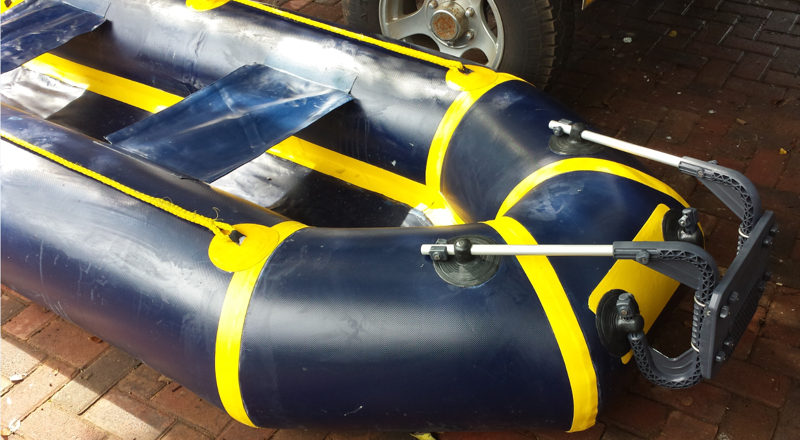

- By using the schematics below, you can easily convert a ski-handle rope into a boarding ladder
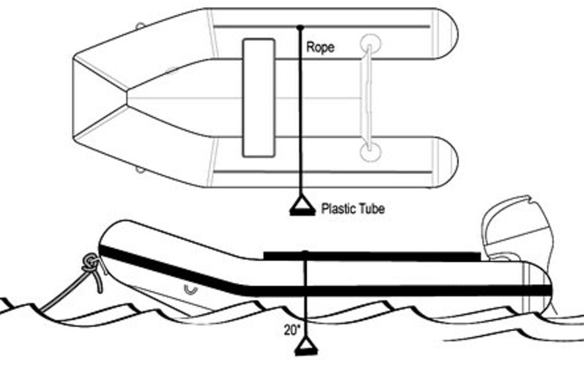

(FAQ) How do I get my boat ashore when I have a major cut in the pontoon & suffer catastrophic air loss?

See interesting YouTube video https://www.youtube.com/watch?v=xlj_A5FsAlU&feature=youtu.be

That’s it for this month. Trust you will be able to add one more camp fire fishing story, to your list of favourites.

Next month when I intend to share some thoughts on the kick-boat & float tube fraternity.

The comments & opinions as expressed in this article, are solely that of Carel Scheepers who can be reached at www.rubberducks.co.za and who is not affiliated to SA Bass magazine in any manner whatsoever.

